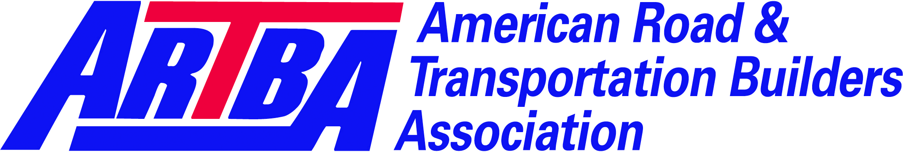

ARTBA Research and Education Division
LTAP/TTAP Member Benefits

Contact: Alison Premo Black
ablack@artba.org
202.289.4434
1219 28th Street NW
Washington, DC 20007
202-289-4435, fax
Since ARTBA was founded over 100 years ago, the Research and Education Division (RED) has played a leading role in the formation of the nation's transportation policy. The division provides an opportunity for academic and research professionals in transportation investment and construction disciplines to have an unparalleled impact on federal policies and programs.
Membership benefits include:
Resources:
- Regulatory, legal and legislative alerts and updates. Including the weekly ARTBA Washington Newsline, an e-newsletter “snap shot” of federal developments impacting transportation construction, new products, services, association news and training opportunities and the Washington Update.
- Access to Member’s only section of www.artba.org includes; Career center, economic and policy studies, ARTBA presentations, current legislative and grassroots campaigns.
- A subscription to Transportation Builder® magazine.
- Economic Analysis and Market Reports - vital information to help you identify business opportunities and market trends.
- Articles for your newsletter publication – most ARTBA articles and stories may be reprinted, with proper attribution, in LTAP/TTAP newsletters or publications. Please check with your division contact or our magazine editor.
A Voice in Washington:
- A direct role in federal transportation legislative and regulatory policy - help improve the funding and structure of federal transportation research programs and increase the contribution from research and education to the performance of the U.S. transportation system.
- Involvement on ARTBA Committees and Councils
Outreach/Networking:
- A listing in our national membership directory - ARTBA's membership directory is the business resource for the transportation construction industry and more than 10,000 copies are distributed annually.
- Share Your Research! Members of the ARTBA Research & Education Division (RED) are invited to submit short papers, studies and research summaries related to the association’s reauthorization efforts from their University, LTAP/TTAP Center or program.
- Communications Staff: help with crisis planning and message development
- S.S. Steinberg Award: the annual division award recognizes an individual who has made an outstanding contribution to transportation education.
- A copy of our annual membership list in MS Excel at a reduced rate - ARTBA's membership roster (a $750 value for $500) includes over 3,000 leading public transportation officials, contractors, finance companies and design firms!
Educational Opportunities:
- Discounts to ARTBA meetings and conventions-meet top executives and leaders of the transportation construction industry and participate in informative policy briefings and technical sessions.
- Member discounts on ARTBA safety products, including our ground breaking, Construction Safety Management Manual, available in CD or hard copy format.
- First-in-Line complimentary safety training materials developed by the ARTBA Safety Department under federal grants with OSHA.
Special Offers to ARTBA Members: ARTBA has worked to provide discounts from preffered providers to help with business costs.
Full List online: http://www.artba.org/links/partners.htm
One example of such a partnership:
ARTBA Members Save BIG on FedEx® Shipping Services
ARTBA and FedEx are proud to announce a new member benefit! As an ARTBA member you are now eligible to receive valuable discounts of up to 26% on select FedEx shipping services:
FedEx Express®: from 15% to 26% on select services
FedEx Ground®: from 4% to 12% on select services
Click here and enter passcode 7TNNXG to start saving now. If you have additional questions, please call 1-800-MEMBERS (1.800.636.2377, 8 a.m.–6 p.m. EST, M-F) to speak to a dedicated member service representative.

