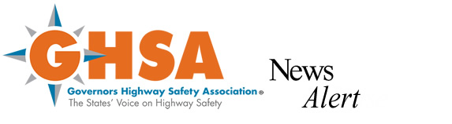

March 30, 2011 CONTACT: Cathy Gillen

FOR IMMEDIATE RELEASE (443) 463-4449 or

[cathy@cathygillen.com](mailto:cathy@cathygillen.com)

**Comments on Crash Data Guidelines Sought**

**Traffic Records Forum Meeting Date and Location Set**

A yearlong process for reviewing and revising the guideline on crash data collection has begun, and comments on the guideline can be submitted online and at a meeting later this year. The Governors Highway Safety Association (GHSA) is managing the update process with funding from the National Highway Traffic Safety Administration.

MMUCC - the Model Minimum Uniform Crash Criteria - is a voluntary Guideline that helps states determine what crash data to collect for a wide range of traffic safety planning applications. The 3rd Edition of MMUCC, adopted in 2008, is available at[www.mmucc.us](http://www.mmucc.us).

“States that incorporate MMUCC data elements into their crash reporting forms and data systems are surprised at how easy the Guideline is to use and how consistent the recommended data elements are with crash data they are already collecting,” said Barbara Harsha, GHSA Executive Director.

A MMUCC Expert Panel consisting of state and local law enforcement officials, state traffic records coordinators, state department of transportation representatives, state health officials, members of the research community and officials from five federal agencies has been organized to oversee the update effort. The Expert Panel is particularly interested in capturing data for emerging issues (such as distracted driving crashes, crashes involving unconventional vehicles, not-on- traffic way incidents) and better defining serious injury crashes and speeding-related crashes.

The Panel is seeking comments to help them with the goal of producing an improved 4th Edition of MMUCC early next year and is asking stakeholders to log on to the Forum section of the website and submit comments to help make this resource the best it can be for safety stakeholders across the country.

A MMUCC meeting will also be held in conjunction with the 2011 Traffic Records Forum which is being held July 31 to August 3 in Charlotte, NC. At the meeting Wednesday afternoon, August 3, stakeholders will have an opportunity to provide input into the next edition of MMUCC. For additional information on the Forum please visit <http://www.trafficrecordsforum.org/>.

-###-

**About the Governors Highway Safety Association**  
The Governors Highway Safety Association (GHSA)® is a nonprofit association representing the highway safety offices of states, territories, the District of Columbia and Puerto Rico. GHSA provides leadership and representation for the states and territories to improve traffic safety, influence national policy, enhance program management and promote best practices. Its members are appointed by their Governors to administer federal and state highway safety funds and implement state highway safety plans. Contact GHSA at 202-789-0942 or visit [www.ghsa.org](http://www.ghsa.org).