Creating Content for your Group

As a workgroup Chair, you will be able to create **Articles**, **Files**, and **Group Meetings.**

**Article**s are time-sensitive pieces of content such as news stories, or recent accomplishments.

**File**s are external documents such as Microsoft Word or Excel files, PDFs, images, etc.

**Group Meeting**s are used to announce upcoming meetings and document past meetings.

# Articles

You should create an **Article** when you want to post a news story or recent information about your group. Your group home page is configured to show the 5 latest articles.

There are 2 ways to create an article. For the first method, you want to be looking at your group’s home page. If you have the appropriate permissions within the group you are viewing, you will see a link to create a **New Article** just below the heading of the *News*list.

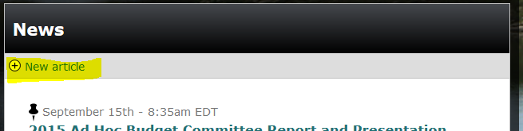  
  
Click that link to create a new article.

You can also click on the **Articles** link in your group’s navigation bar. On the following page, just below the *News* heading, you’ll see the same link to create a **New Article.**

Clicking on either link will send you to the *Create a New Article* form.

Fill out each field in the form. The fields that need filling out are listed below:

* **Title**This is the title of the article that you are creating. It should be succinct. It will be displayed in your group’s news feed as well as at the top of the individual article.
* **Groups Audience**This is the group to which the article belongs. If you clicked on the **New Article** link on your group’s homepage or article page, the group will be pre-filled. If you belong to multiple groups, you can choose to assign the article to a different group by selecting it from the drop down menu.
* **News Item Content**This is the “meat” of your article.

Once these fields are filled out, click on the **Save** button at the bottom of the form. That’s it. Your article now appears in your news feed.

# Meetings

You should create a **Meeting** when you need to notify your group members of an upcoming meeting.

Like articles, there are two ways of creating a meeting. On your group’s home page, on the left side, there is an *Upcoming Meetings* block. Directly below that header is a link to create a **New Meeting.** Click on that link.

You can also click on the **Meetings** link in your group’s navigation menu. Just below the page title of the next screen, click the **New Meeting** link.

Clicking on either link will take you to the **Create Group Meeting** form.

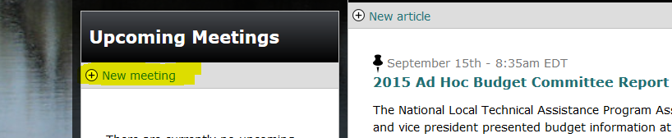

Fill out the form as completely as possible. Descriptions of form fields:

* **Title**This is the title that will be displayed on the *Upcoming Meetings* block, the calendar, and past meetings.
* **Groups Audience**This is the group to which the article belongs. If you clicked on the **New Article** link on your group’s homepage or article page, the group will be pre-filled. If you belong to multiple groups, you can choose to assign the article to a different group by selecting it from the drop down menu.
* **Date and Time**If you know when your meeting is going to end, ensure that the box next to **Show End Date** is checked. This will allow you to specify the time at which the meeting will end.  
    
  By clicking inside of either **Date** field, a calendar will pop up. Simply click on the date that the meeting starts and ends to set the date field to that day. You can do this with both the start and end dates.  
    
  Fill in the time at which the meeting takes place. Enter the time for your time zone. The time zone is automatically translated to other user’s time zones based on the time zone they select in their profile.
* **Body**This is where you fill in details about the meeting. Maybe what the meeting will cover, webinar connection details, etc.
* **Meeting Files**You can attach files to your meetings.   
    
  Under **Upload a File**, click on **Browse** to search your computer for files. Only certain file types are allowed. They are listed below the field. Then select the **File Category** by using the dropdown.  
    
  You can add another file by clicking **Add another item** below the **Meeting Files** section. There is no limit to the number of files you can attach.

Click on **Save** to create this meeting. Upcoming meetings are added to the group’s home page, the group’s meeting page, and the group’s calendar.

# Files

You can create a **File** content type to add an external document to your group. Use **File**s to upload Word files, Excel spreadsheets, PDFs, images, etc.

You can create categories for your files. We’ll go through this process first

## File Categories

To view and create file categories, go to your group’s file page by clicking on the **Files** link in your group’s navigation menu. On that page, just below the group navigation bar, click on the **Edit file categories** link.

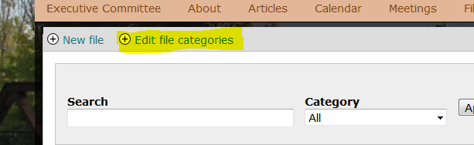

To view what terms are available for file categorization, select **list terms**. You can also add terms from this page. If you just want to add a term, click on **Add Terms.**

Once you click on the **Add Terms** link, you’ll be taken to a form. Fill out the form. Fields are listed below.

* **Name**  
  This is the name of the category that you are adding. It will be added to the drop down list when selecting a file’s category.
* **Description**This field is optional and the description is never seen by anyone but those who can create terms. Describe how this category should be used.
* **Sticky on Group Page?**  
  Check this box if you want terms in this category to be displayed on the group’s home page. All files in this category will appear at the bottom of your group’s home page. Uncheck this box to disable it.

Click on **Save.** Your category is now available to add to files.

## Files

Now that you have a file category, you can upload a file.

Visit your group’s Files page by selecting the **File** link from your group’s navigation bar. On the next page, select **New File**.

Using this form, you can add a file to your group. Fill in the fields to add the file:

* **File Name**  
  The name of the file that is displayed in lists.
* **Upload a File**Hit the browse button to search for a file on your computer to upload. After selecting it, hit open in the modal window, then click the **Upload** button.
* **Groups Audience**This is the group to which the article belongs. If you clicked on the **New File** link on your group’s homepage or article file, the group will be pre-filled. If you belong to multiple groups, you can choose to assign the file to a different group by selecting it from the drop down menu.
* **File Categories**Select a category for this file from the dropdown. These are the categories that you created during the last step.
* **Sticky on Group Page**Check this box to display this file on the group’s homepage. Uncheck it to hide it.

Click on save to create this file. It will appear in your group’s list of files, and on the homepage if it has been configured as such.