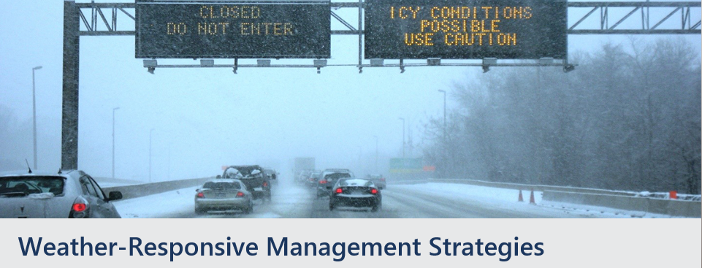

* Develop a framework to help determine if and where Variable Speed Limits (VSL) are warranted based on speed and crash studies during weather events. Develop and incorporate rules or a formula for speed reduction into standard procedures.
* Develop or update the agency website and 511 system to incorporate existing and forecast weather-related roadway and traffic condition information.
* Develop a mobile app that provides road weather related information to the travelers and the transportation agency using field observations or connected vehicle data.
* Design and install variable message signs to disseminate road weather information to the travelers including low visibility, icy road conditions, water or debris on the roads and high winds.
* Develop or adopt a route optimization software for snowplows that uses road weather, traffic, road network characteristics, garage locations and cost parameters.
* Develop or adopt a tool for visually tracking location of snowplows on the road, the sections that have been maintained, and the amount of salt and chemicals that have been applied.
* Implement Maintenance Decision Support System (MDSS) or other winter maintenance management software/tool that provides treatment recommendations for icy or snow-covered roads (including pre-treatment) into the standard procedures.
* Develop Concepts of Operations for Weather-Responsive Traffic and/or Maintenance Management Strategies, focusing on those strategies that would yield the most benefit for the agency. Depending on funding level, this could also be expanded to translate the concept of operations into high level requirements and system design.
* Install mobile road weather sensors and other advanced technologies including AVL/GPS, friction sensors, radar detection systems and cameras on vehicles or snowplows to obtain site-specific data to support traffic and maintenance management strategies.
* Utilize field data collections devices including tablets, smart phones and other PDA’s to record and transmit road weather information to data processing centers (i.e. TMC’s) or other travelers and field crews.

*Contact:* ***Roemer Alfelor;*** *(202) 366-9242;* [*Roemer.Alfelor@dot.gov*](mailto:Roemer.Alfelor@dot.gov)

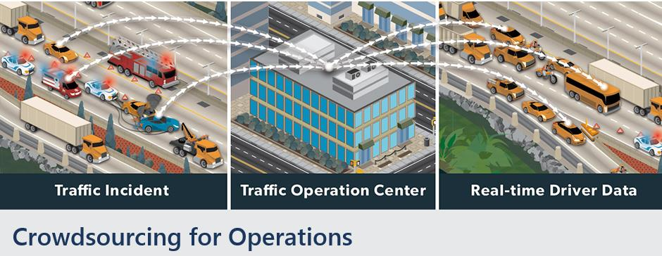

* Conduct an evaluation of the feasibility (including potential use cases and applications, benefits, costs, challenges, and risks) of using crowdsourced data sources in a region or state for operations to help build a business case.
* Develop a Regional or Agency-specific Crowdsourced Data for Operations Strategic Plan that is based on planning for operations concepts.
* Develop written business processes to guide the use of crowdsourced data in support of operations activities.
* Review state data analytics processes to identify more efficient strategies to demonstrate the application of crowdsourced data and making the business case for crowdsourced data.
* Develop performance measures based on crowdsourced data that are consistent with the organizations goals and objectives.
* Develop Systems Engineering documents (Concept of Operations, Requirements, Validation and Verification Plans, etc.) for integrating crowdsourced data into existing traffic management platforms and systems.
* Integratecrowdsourced and traditional data sources into a unified database.
* Develop tools and/or purchase software, software, and/or storage devices to enable the real-time collection, dissemination, and application of crowdsourced data.
* Modify existing TMC or CAD software to include crowdsourced data.
* Develop or update the agency traveler information platforms (website, 511 system, social media, etc.) to incorporate crowdsourced data.
* Pilot a small scale demonstration to build trust with a third party crowdsourced data provider(s).
* Negotiate and execute an agreement with a third party crowdsourced data provider(s).

*Contacts: James Colyar; (360) 753-9408;* [*james.colyar@dot.gov*](mailto:james.colyar@dot.gov)

*Paul Jodoin, (202) 366-5465;* [*Paul.Jodoin@dot.gov*](mailto:Paul.Jodoin@dot.gov)

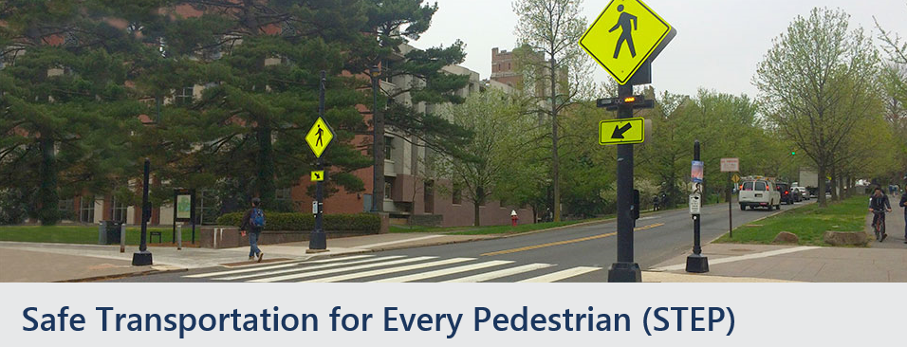

* **Marked Crosswalk Inventory:** Develop a crosswalk inventory. This can be done using GIS to located all mid-block and intersection crosswalks with the State.
* **Identify statewide STEP countermeasure to deploy:** Using Data Driven Safety Analysis, use data or physical attributes of the roadway and pedestrian network (vehicle speed, system connectivity, crossings, transit placement and access management), to determine the STEP countermeasures to deploy and improve pedestrian safety and mid-block crossing locations using information from the [Guide for Improving Pedestrian Safety at Uncontrolled Crossing Locations](https://www.fhwa.dot.gov/innovation/everydaycounts/edc_4/guide_to_improve_uncontrolled_crossings.pdf).
* **State and Local Partnership:**  Develop a partnership with local communities to pilot STEP countermeasures at specific locations. FHWA could provide training to the local agencies in conjunction with providing the funding for these pilot locations.
* **Pedestrian Safety Conference**: Host a one-day statewide pedestrian safety conference and invite all stakeholders at the state, local and not-for-proftit levels (engineers, planners, advocates, ped/bike professionals) to discuss the state of pedestrian safety and learn about the STEP countermeasures.
* **Marketing Video**: Develop a video showcasing the use of STEP Countermeasures (Road Diets, pedestrian hybrid beacons (PHBs), pedestrian refuge islands, raised crosswalks and crosswalk visibility enhancements) within the state.  Oklahoma did this in their state to advance STEP, and New Jersey and Ohio did this in their states to advance Road Diets and had major success.
* **Statewide Planning for STEP Countermeasures**:  Using pedestrian crash data at mid-block crossing locations, work with local agencies to analyze and conduct engineering studies statewide to determine the most appropriate STEP countermeasures.
* **Development of Guidelines for Marking Mid-Block Crosswalks at Uncontrolled Locations on Multi-lane, High Volume Roadways:**  Develop guidance relating to the marking of crosswalks at controlled locations (those controlled by signals, stop signs, and yield signs), uncontrolled locations (intersections and midblock), and unconventional intersections and locations. It should describe various crosswalk treatments, including the countermeasures in STEP, and guidance as to when to use them. There should also be a public education component on the guidance.
* **Road Diet Guidance**:  Develop guidance relating to Road Diets or roadway reconfiguration to improve safety, livability and accommodation of all highway users.
* **Online training**:  Develop an online training that emphasizes general guidelines for placement of midblock crosswalks (*Pedestrian Facilities Users Guide-Providing Safety and Mobility,* FHWA-RD-01-102 or state guidance) that could be accessed by state, locals and tribal agencies.

*Contacts: Becky Crowe; 804-775-3381;* [*Rebecca.Crowe@dot.gov*](mailto:Rebecca.Crowe@dot.gov)

*Peter Eun; (360) 753-9551;* [*Peter.Eun@dot.gov*](mailto:Peter.Eun@dot.gov)

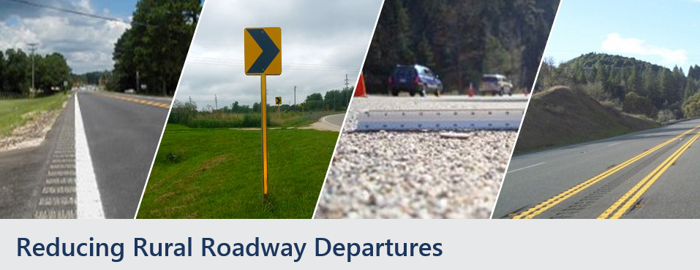

Develop a variety of products to improve systemic application of countermeasures on all public roads (FHWA can assist). May include:

* Create a tool or processto make rural roadway departure crash data available to State district/region and rural counties as well as other pertinent local, tribal, or federal agencies with significant number of miiles of high speed rural roads.
* Develop risk factors for rural roadway departures based on crash, volume, roadway and other data.
* Create a systemic process tree diagram based on risk factors for each facility type for rural roads.
* Develop local road safety plans with a rural roadway departure emphasis in one or more counties
* Develop region/district safety plans with a rural roadway departure emphasis
* Review State DOT existing policies, processes, and procedures to identify opportunities to incorporate more-systemic safety applications in all projects, including maintenance.
* Collect and/or integrate local road data to improve safety on all rural public roads.
* Develop network screening processes to identify sites with the highest potential for improvement
* Host training and workshops for systemic analysis and design (FHWA can assist)
* Host in-state peer exchanges to assist local agencies in implementing systemic Roadway Departure countermeasures (FHWA can assist)

*Contacts: Cathy Satterfield; (202) 309-0465;* [*Cathy.Satterfield@dot.gov*](mailto:Cathy.Satterfield@dot.gov)

*Dick Albin; (303) 550-8804;* [*Dick.Albin@dot.gov*](mailto:Dick.Albin@dot.gov)

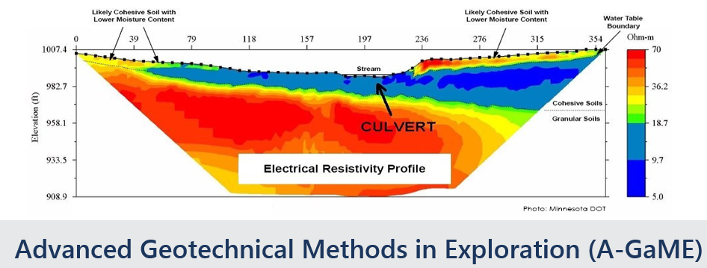

**Codes & Standards**

* Develop standard language related to variability, risk, geostatistics, and similar for State and FHWA guidance documents (and later AASHTO); develop standards for regular procurement and alternate delivery (perhaps develop contractual methods to incentivise risk reduction/retirement by using geophysics or other remote sensing techniques (LiDAR, InSAR, etc).
* Develop standard language to ensure geotechnical investigations are performed with adequate care and investment (rather than a loss-leader to get material testing work afterward). Perhaps develop a payment framework where construction funding can be used to reimburse/pay for investigation (e.g. pre-project QC material testing).

**Standardization**

* Develop a DIGGS export/import tool for gINT (or stand alone batch file) that will take state-specific gINT (or other formats) and allow them to import or export to the current DIGGS schema. Note that this could speed adoption and implementing the DIGGS standard.
* Develop standard contract specification for geophysical services (if not available in-house, or in addition to in-house geophysical services)
* Develop standard contract specifications for OTV/ATV and other borehole techniques
* Develop standard contract specifications for LiDAR and InSAR (movement study) techniques.
* Develop Standards for geophysical data transfer (consistent with DIGGS schema) and representation
* Develop new risk- and reliability-based guidelines for subsurface investigation criteria for SHA/Local Geotechnical Manuals.

**Implementation**

* Implement the use of and provide user-training of Measurement While Drilling instrumentation, display, and software
* Pilot the use of Visualization Software for subsurface characterization and model development on a project. Provide lessons learned to others around the state to share the benefits and challenges.
* Implement the use and provide user training on geophysical testing equipment (Electrical Resistivity, Seismic geophones/accelerometers, instrumented sources, etc.) for SHAs andLocal Agencies.

*Contacts:* ***Ben Rivers;*** *(404) 562-3926;* [*Benjamin.Rivers@dot.gov*](mailto:Benjamin.Rivers@dot.gov)

***Silas Nichols;*** *(202) 336-1554;* [*Silas.Nichols@dot.gov*](mailto:Silas.Nichols@dot.gov)

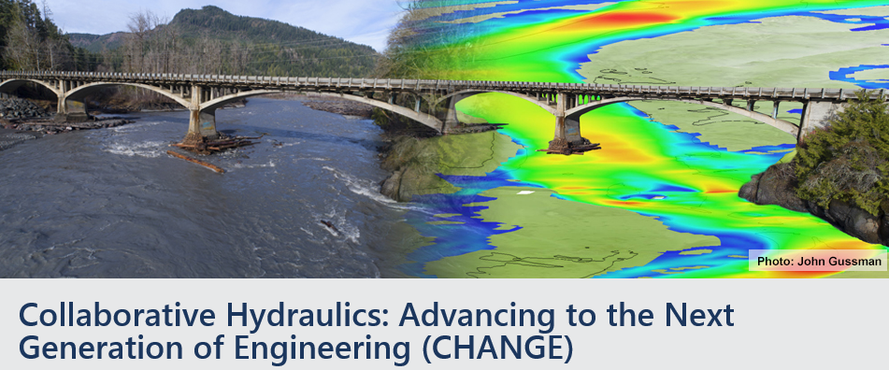

* Host NHI Training Course 135095 on 2D Hydraulic Modeling and NHI Online Training Courses 135095A&B on 2D Hydraulic Modeling
  + Supplement FHWA scholarships to send additional staff
  + Host training for local public agencies (FHWA can assist with these)
* Facilitate collaboration meetings/workshops with resource and other agency staff
* Modify policy documents, procedures, other implementation/guidance documents to incorporate 2D Hydraulic Modeling into statewide processes
* Convene a workshop with leaders and technical experts to better understand benefits and help overcome misconceptions.
* Perform a project assessment – Perform 2D modeling on a past or upcoming project and compare results with current 1D modeling approach to create lessons learned for future projects.

*Contacts: Scott Hogan; 720-576-6026;* [*scott.hogan@dot.gov*](mailto:scott.hogan@dot.gov)

*Eric Brown; 410-962-3743;* [eric.r.brown@dot.gov](mailto:eric.r.brown@dot.gov)

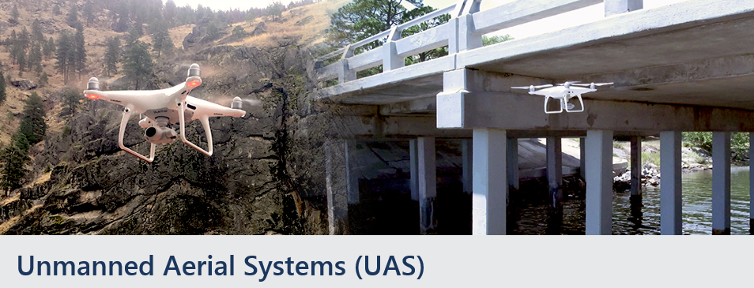

* Develop processes and tools for selecting the right UAS platform or determining if a UAS is the right tool for a specific use.
* Develop and implement a UAS program, including testing the UAS platform to develop lessons learned, developing standard processes, and providing training statewide to DOT regions and local public agencies on how to use the data obtained by the UAS Program.
* Develop and provide training for UAS pilots.
* Host a workshop with other Agencies within your state, Local Agencies, Subject Matter Experts, and/or neighboring States.
* Provide training for Geospatial tools use to advance data use collected by UAS technology

*Contacts:  James Gray; (703) 509-3464;* [*James.Gray@dot.gov*](mailto:James.Gray@dot.gov)

*Connie Yew; (202) 366-1078;* [*Connie.Yew@dot.gov*](mailto:Connie.Yew@dot.gov)



* Evaluate Value Capture Funding and Financing options applicable to local programs. There is no one size fits all. Each local jurisdiction is structured and operate differently.
* Host clustered local peer exchange events throughout the state for sharing opportunities and challenges in implementing value capture funding mechanisms.
* Develop local policies for Value Capture Mechanisms use & selection approach including assisting locals in crafting communication & messages to their public officials in support the use of value capture mechanisms
* Host workshops/peer exchanges, develop strategies, and process to integrate life cycle cost of the project into decision making process.
* Develop capital improvement programs with integrated funding and financing strategies
* Conduct Value Capture funding outreach to locals & MPOs
* Host a Technical Workshop (facilitated by FHWA Exploratory Advanced Research Team) to:
  + Craft a Capital Improvement Program and Project Management Strategy to Advance Multi-jurisdictional Transportation Needs including incorporating Value Capture & Innovative Finance tools (workshop facilitated by FHWA Exploratory Advanced Research Team)
  + Craft a Capital Improvement Plan and Comprehensive Project Execution Toolkit for Gateway Community Partnerships - Federal Land Managers/Tribes, Local Officials, and Stakeholders (technical workshop facilitated by FHWA Exploratory Advanced Research Team)
  + Align Projects to optimize Value Capture Revenue Mechanisms - Economic Development with Social Justice
  + Model for Accelerating Prosperity - technical knowledge networks for specialty analytic tools, in this case (1) Connected Vehicle Environments for Freight Oriented Development scan tour; (2) Trip Demand Reduction through Business Recruitment peer exchange; and (3) a peer exchange/report on Adapting the 1981 P&G and IWRM to Capital Improvement Plans
  + Create a Capital Improvement Program for Wildlife-Vehicle Collision Countermeasures

*Contacts:* ***Stefan Natzke;*** *202-366-5010;* [*Stefan.Natzke@dot.gov*](mailto:Stefan.Natzke@dot.gov)

***Thay Bishop;*** *404-562-3695;* [*Thay.Bishop@dot.gov*](mailto:Thay.bishop@dot.gov)

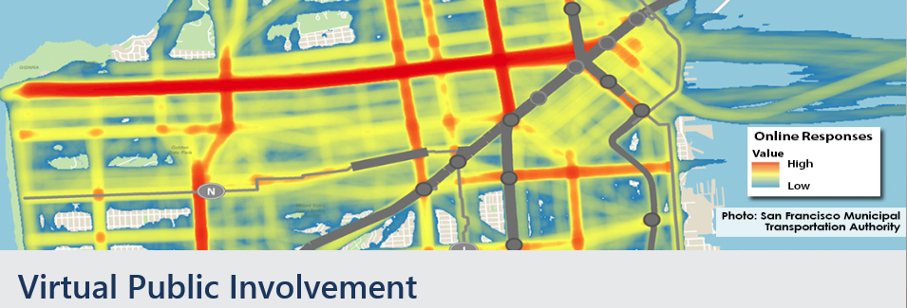

**Tools & Apps**

* Implement the use of digital tools for transportation planning and programming, transportation plan development, congestion management process, or transportation improvement program.
* Incorporate the use of virtual tools into standard public involvement processes to enhance project development and environmental review processes in order to facilitate more effective participation from stakeholders and the public and to provide transparency of project development activities.
* Develop customized mobile application/website to enhance public involvement on a major project.
* Develop meeting-in-a-box kits to enable community groups to host their own public meetings and gather input a transportation plan, visioning, or other activities in the planning process.
* Develop and provide training in the use of digital tools, apps, and related technologies.

**Social Media**

* Develop and document a strategy for communicating with the public and gathering public input via social media as part of a more comprehensive public participation.
* Pilot the use of live-streaming during public meetings via social media feeds and collect feedback live and after the fact. Capture the lessons learned to share statewide and with local agencies.
* Develop a framework to analyze and process social media interactions and categorize as public input for planning and project development activities.
* Develop and share low-cost videos through social media channels to inform and engage the public in project-level input opportunities. Share your lessons learned with other agencies in your state.
* Develop and provide training in the strategic use of social media by public agencies to involve stakeholders in planning and project development.

**Visualizations & Public Information Media Campaigns**

* Implement the use of GIS visualizations or StoryMaps to help with scenario planning or project development public involvement activities. Use the lessons learned to develop standard guidance.
* Implement the use of 3D visualizations of an upcoming project to help the public better understand and participate in project design. Use the lessons learned to develop standard guidance.
* Implement the use virtual reality or augmented reality technology to enhance project visualizations.
* Develop and provide training to advance staff technical skills related to visualizations and GIS.
* Develop a framework to create targeted adds in new media to supplement traditional media.

*Contacts:* ***Scott Allen;*** *(202) 366-2650; Scott.Allen@dot.gov*

***Jody McCullough;*** *(202) 366-5001;* [*Jody.McCullough@dot.gov*](mailto:Jody.McCullough@dot.gov)

***Harold Peaks;*** *(202) 366-1598;* [*Harold.Peaks@dot.gov*](mailto:Harold.Peaks@dot.gov)

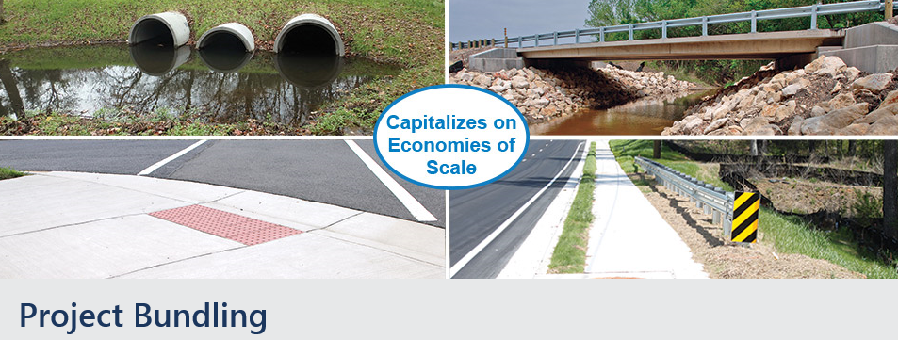

* Sponsor outreach event to raise stakeholder awareness of project bundling benefits.
* Develop process/tool for project selection during programming, including risk assessment.
* Develop planning and design tools for taking advantage of project development efficiencies of bundling, such as combined NEPA/permitting, programmatic agreements, pre-fabricated bridges and systems, standardized design, construction means/methods.
* Develop process/tool for project delivery and procurement method selection.
* Develop state-specific guides, workflows, checklists and specs/contracts.
* Implement web-based applications that allow for greater collaboration during project development and construction, within the DOT and with consultants and contractors.
* Host a peer exchange/scan to learn from lead states.
* Develop change management or implementation plan - incorporate bundling as a strategic tool
* Pilot a bundle of projects to learn better ways to fund, develop and deliver as a strategic solution
* Develop standard approach for construction management/quality assurance and project accounting
* Develop a framework to evaluate state and local assets to determine if common challenges could be effectively met by bundling projects.
* Develop tool for estimating return on investment and capturing actual values of contract execution.

*Contacts:* ***Romeo Garcia;*** *(202) 366-1342;* [*Romeo.Garcia@dot.gov*](mailto:Romeo.Garcia@dot.gov)

**David Unkefer;***(404) 771-1971;* [*David.Unkefer@dot.gov*](mailto:David.Unkefer@dot.gov)