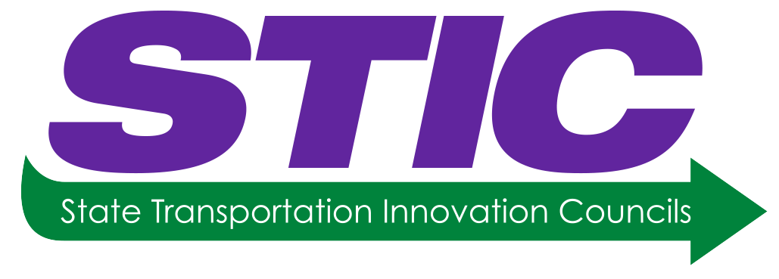

**National STIC Network Meeting**

April 11, 2019 at 2:00 pm – 3:00 pm (Eastern)

**Registration Link:** **[https://collaboration.fhwa.dot.gov/dot/fhwa/WC/Lists/Seminars/DispForm.aspx?ID=1938](https://collaboration.fhwa.dot.gov/dot/fhwa/WC/Lists/Seminars/DispForm1.aspx?ID=1938)**

*Send any questions you may have to* [*Sara.Lowry@dot.gov*](mailto:Sara.Lowry@dot.gov)

**Final Agenda**

**Welcome and Introduction**

*Brandye L. Hendrickson,* FHWA Deputy Administrator

**Pennsylvania STIC: Moving Innovation Forward**

*Danielle Klinger-Grumbine* and *Anja Walker,*

Pennsylvania Department of Transportation | Bureau of Innovations

Link to PA STIC website including 2018 Year-End Report:

<https://www.penndot.gov/about-us/StateTransportationInnovationCouncil/Pages/default.aspx>

**Pathways to Ingenuity, “What we heard at the EDC-5 Summits”**

*Jeff Zaharewicz* and *Sara Lowry,* Center for Accelerating Innovation

**Innovation Updates**

*Tony Furst*, FHWA Chief Innovation Officer

*Thomas Harman*, Center for Accelerating Innovation

*(3:00 pm End of Webinar Feed & Network Meeting)*



**Local STIC Discussion**

April 11, 2019 at 3:00 pm – 3:30 pm (Eastern)

**Moving Innovation Forward: Communication is Key! – Local Discussion**

See next page for some discussion topics

**Moving Innovation Forward: Communication is Key! – Local Discussion**

The idea behind this section of the agenda is for STICs to have some general discussions about innovations in your state and to explore further the topics you heard today. For those that are not meeting today, the below can be a starting discussion for your next local STIC Meeting. Take as much or as little time as you need with the below discussion, **this is your discussion about moving innovation forward and communicating about innovations in your state**.

* Think about ways to provide proactive communication to engage the public, the press, and your elected officials in the innovative practices and great things that you are doing throughout your state.
  + Are you engaging your public information office when you are planning to try an innovation?
  + Are you engaging the public and making them aware of your successes?
* How does your STIC communicate about innovation? Start by having a conversation about your objectives, your target audiences, your message, timeframes, your communication outlets, and ways to get feedback. (Share your written plans with CAI and with others in the STIC Network.)
* What items did you discuss at the EDC Summit during the Research to Practice session?
  + Are there any actions your STIC should take to help bridge the gap between research and practice?
  + Are there existing groups already meeting within your state – should additional members be added to these groups to help bridge the gap between research and practice?
* How are you letting your STIC know about research that is being completed and how is the STIC helping to inform the next research projects?
  + How are you feeding the innovation pipeline?
  + Do you have a research roadmap?
* How does your STIC plan to use innovation funding?
  + Are there opportunities to use the STIC Incentive funding ($100,000 to institutionalize innovation per fiscal year) this fiscal year (FY19) and next fiscal year (FY20)?
  + Do you have project that could be a good fit for the AID Demonstration program (up to $1 Million for innovation added to project)?
* Share with each other how you and your organization maintain “situational awareness”. What ideas are you reading about that you are most excited about?
  + Will these address your biggest challenge?
  + How can the STIC help get ready for these new ideas?
  + Have you considered meeting or communicating with neighboring STICs to see if they are having a similar challenge / or found a solution?