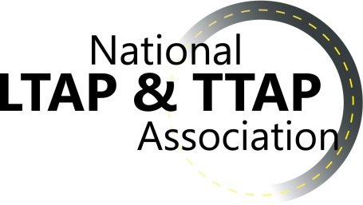 NLTAPA Work Group

Report of Activities

**Work Group: Safety Date: 6/18/18**

**__________________________________________________________________**

**WG meetings since last EC call**: May 17, June 6

**Upcoming Meetings**:

* none

**Highlights**:

* Spring webinars:
  + May 17: The webinar on the Colorado Innovations Conference (Renee Railsback, CO LTAP) went very well. We had 8-10 Centers participate. Renee had an excellent presentation about how and what they did for this conference. There was a good question and answer dialogue at the end.
  + June 6: The webinar on New Proven Safety Countermeasures (Rosemarie Anderson & Jeff Shaw, FHWA) did not end up working. We only had 3 participants join the webinar. So the event was cancelled. Presentation information was shared, but we will plan to hold this webinar in the fall. One of the questions we will ask the safety work group at our meeting in New Orleans will be about topics and/or timing of webinars (as the lesson learned may be that summer months are not ideal for these webinars).
  + Conference Workshop/Sessions: Nearly all details for the safety activities at the conference are finalized. We are just awaiting one final name (a local from Louisiana) for the Local Road Safety Plans session.
* The LTAP safety peer exchange is underway with planning (Sept. 11-12 in Kansas City, MO). The peer exchange will include LTAP and DOT representatives from the participating states. Thus far, 11 of 12 invited states have agreed to participate. States are currently finalizing the list of participant names.
* One of the safety work group co-chairs is no longer with LTAP (Nicole Frankl, NE LTAP). Therefore, we will be looking for a new co-chair for the work group. It is anticipated that we will add Laila Kral (ID LTAP) as a co-chair, as she will be joining the EC as the Western Region representative in July.

**Reported By**: Matthew Enders (WA), Safety WG Co-Chair